|  |
| --- |
| CS 440 |
| Programming Languages and Translators |
|  |
| MCL: Lex analyzer report |
| 02/12/2017 |

|  |
| --- |
| Yuyang Luo  [yluo41@hawk.iit.edu](mailto:yluo41@hawk.iit.edu)  Cai Chen  zdthm007@gmail.com |

# Tokens in MCL language

Basic element:

Digit: $[0-9]$

ID: (_)? $\left[a-zA-Z\right]{\left[a-zA-Z0-9\right]}^{*}$

Array: "{"" "*[0-9]+(" "*","" "*[0-9]+)*" "*"}"

Basic Data;

integer: {Digit}+

matrix: ID

matrix element: ID\[\s integer, integer\s\]

Keyword:

Data Type: int |matrix

Operators:

"+"|"-"|"*"|"/"|"="

Punctuations:

"("|")"|"["|"]"|","|";"

Space:

[ \t\n\r]+

Comments:

Same style like c and c++ comments, everything between “/*” and “*/” or “//” and “\n” are comments

\/\*([^*\"]*|\".*\"|\*+[^/]|\")*((\*\/)|(\*\*\/))|\/\/[^\n]*

# Finite machine

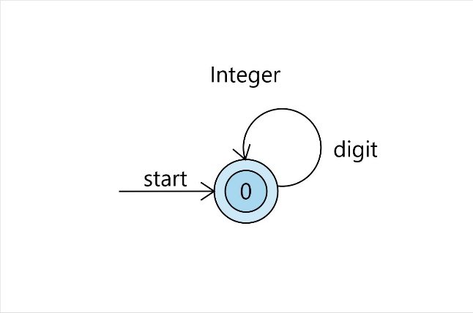

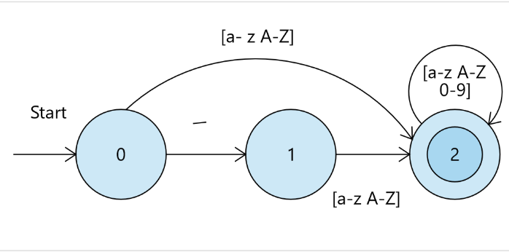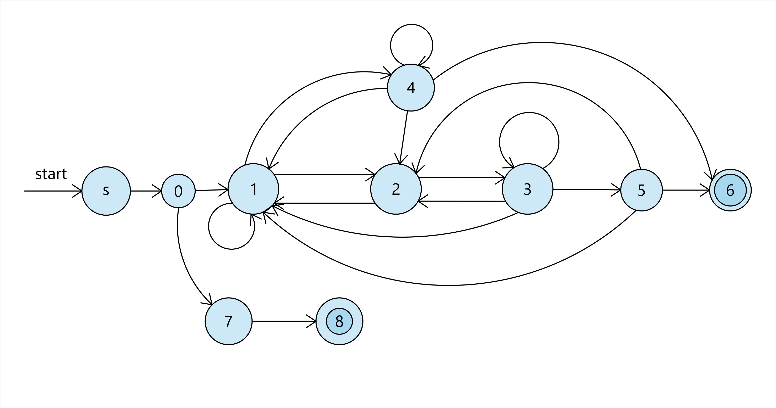

[^”]

\*

[^\n]*

\/

[^\*”]*

”

”

[^\/\*”]

\*

$

\/

\*

\/

\*

”

”

”

[^\/\*”]

\*

\/